**‘**

**South East Association of Directors of Adult Social Services (ADASS)**

**Connected Communities – Our Vision for Adult Social Care**

**18 Local Authorities**

* Bracknell Forest
* Brighton & Hove
* Buckinghamshire
* East Sussex
* Hampshire
* Isle of Wight
* Kent
* Medway
* Oxfordshire
* Portsmouth
* Royal Borough of Windsor & Maidenhead
* Reading
* Slough
* Southampton
* Surrey
* West Berkshire
* West Sussex
* Wokingham

**South East Region Local Authorities and Integrated Care Board Boundaries**

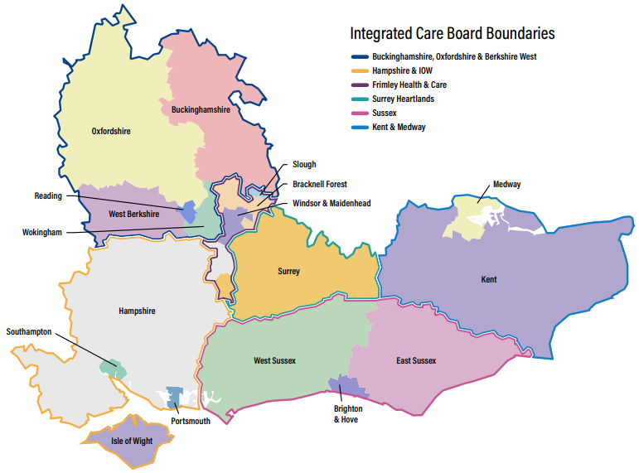

**6 Integrated Care Boards**

* Buckinghamshire Oxfordshire & Berkshire West
* Hampshire & Isle of Wight
* Frimley Health & Care
* Surrey Heartlands
* Sussex
* Kent & Medway



**Introduction from the Co-Chairs**

This document has been co-produced with senior leaders across the South East region, with the purpose of sharing our vision for care and support, confirming our ambitions, and cementing our strategic intentions for the future.

We know there is so much to be proud of in the region, ensuring that our residents continue to live well and at home. Well-functioning adult social care services in local communities, that are at the heart of maintaining people in safe, healthy, fulfilling lives, are so important.

We have an ambition in the South East to change the way adult social care is delivered. In adult social care we work with people from a position of their strengths, focusing on what people can do rather than what they can’t do. We use our skills, resources and experience to build on people’s individual strengths and to think creatively about how to maximise the positive impact we can have, with the money and capacity that is available.

We believe that through collaboration, communication, and working with people who use services, family carers and service providers working together we can deliver this ambition.

We have an opportunity to do something fundamentally different that focuses more attention on enabling people to live their best lives at home and be active in their local communities and prevent the need for long-term health and social care support.

We need a diverse range of high-quality services which seek to respond to people’s changing needs and which support local employment and community wealth. We have the chance to reimagine the care that we all want for ourselves and our families.

**Alan Sinclair and Grainne Siggins**

**South-East ADASS Co-Chairs**



**Connected Communities - Our South East Adult Social Care Vision**

**Our ambition is to provide “*the right care and support to people at the right time and in the right place”.*** We recognise that we all want **to***live fulfilled lives* ***in****a place we call home****with the people and things****we****love, in communities where****we****look out for one another, doing the things that matter to us*[1].**



**Connected Communities - Our South East Adult Social Care Vision**

Adult social care and support primarily takes place in communities, in people’s homes, where the focus is on helping people to stay well and independent for as long as possible. The aim is to maximise and prioritise health and wellbeing to prevent or delay people developing health and care needs. Adult social care is a key partner of the NHS, however supporting hospital discharge represents only a small proportion of adult social care activity, currently around 19%[2]. Just as in the NHS, ‘prevention is better than cure’ so our ambition is to achieve a better balance between the current focus on acute hospitals and the invaluable but under resourced community sector.

Our health, social care and housing services are struggling to meet their statutory requirements to provide people with timely, safe, high quality and effective care and support due to increasing demands and reducing funding.

Care and support is an essential part of our social and economic infrastructure and is consistently undervalued and overlooked for investment. Social care contributes over £50bn to the UK economy. For every £1 invested, it generates £1.75 - ‘*Future Social Care Coalition’.*

We want to work as equal partners with people who draw on support and be able to support people in the way they choose to be supported rather than focusing on a priority list of statutory needs only.

We want to reimagine care and support jointly with health and housing partners and with people with lived experience of receiving support so we can support more people to live fulfilling lives in a place they call home, give better support to carers, focus on a sustainable long term workforce plan, and build community capacity that values wellbeing.



**Vision for people in the South East**

Our vision is to provide ***the right care and support to people at the right time in the right place***. We want people to live fulfilled lives with support from family and friends within their communities and networks as well as being able to access high-quality, tailored, inclusive care and support from caring, supportive and enabling people in a way that suits their values and their lifestyle.

SE ADASS is in a strong position to reimage and reignite adult social care. Social care is about all of us. It has a huge impact but sometimes the social care workforce can feel invisible and undervalued.

Over the years we have listened to people expressing their views on how care and support is delivered – and they have told us they want to:

* make a contribution
* have choice, independence and control
* be active members of families and communities
* flourish and live life to the full
* be free from discrimination and feel valued

We also hear from people who draw on our support. People want a system that is focused on outcomes and wellbeing, personalised, sustainable, effective and efficient, integrated and coordinated, proactive and preventative, that is local, and community based.

Based on this, in the SE region we are committed to:

* reimagining good quality inclusive care and support in our neighbourhoods to ensure people stay well and live longer at home, enabling them to lead a good life, placing co-production at the heart of what we do, and giving better support to carers
* people getting support and advice easily, when they need it, so that crises are avoided
* driving good quality inclusive practice and standards influenced by sector-led improvement
* preparing well for, and delivering identified improvements following, CQC assessment, all as part of our business as usual
* harnessing the potential of digital technology and tech enabled care, and building a flexible sustainable skilled workforce, that is valued and respected to meet future needs
* embracing and connecting communities to promote a strength-based approach seeing people’s contributions as assets through a broader lens of experience, knowledge and skills
* promoting high quality community offers of support that promote a person’s wellbeing physically, mentally, educationally, emotionally, and financially to achieve better outcomes for people

What does this mean for social care professionals?

* Working to what matters to you, not what is the matter
* New ways of working building upon the core values of social care practice
* Changing our systems and processes to enable them to become strength focused in design and application
* Supported to work creatively, effectively, inclusively and collaboratively
* Experience a richer working environment with high satisfaction rates for staff and the people we serve

And our systems

* Partnerships and investment within our communities; our voluntary, community, faith and social enterprise sector, and our health and social care partners to enable a community first response supported by services when needed
* Changing what we do through adopting strength focused, community first approaches

As leaders in the South East, the role of our Directors is to innovate, commission differently, promote a culture of inclusivity and positive risk taking, and be a strong leadership voice that can articulate the value and purpose of adult social care at national and regional level through national ADASS, the Local Government Association (LGA) and in Partners in Care and Health (PCH). We want to articulate the strength of collaboration across our communities, ensuring equity and inclusion and we strongly believe we need to strengthen the economic case for social care.

It is time to reignite the strong position of adult social care in reform and transformation: we want a simple system that works. Our ambition and vision with our six priority objectives have set our direction of travel for the SE region.

**The Economic Case for Adult Social Care**

Skills for Care[3] estimates that there are 270,000 filled posts in the adult social care sector in the South East. Social care contributes over £50bn to the UK economy. For every £1 invested, it generates £1.75 - ‘Future Social Care Coalition’. The economic contribution of social care in the South East is considerable: with Gross Value Added (GVA) estimated at £8,310 million – the largest figure for any English region.





**Our strategic intent and priorities for the region**

To achieve our vision, we have identified six priority objectives for 2024/5 which link with our vision and with ADASS’s priorities nationally.

**1. Reform & Transformation in Partnership, 2. Strategic Commissioning, 3. Strategic Workforce Planning, 3. Social Justice & High Quality Practice, 4. Finance & Resources and 5. Digital, Data & Intelligence**.

Whilst it is right to set out our ambitions, we must also recognise the severe financial and workforce constraints facing all local authorities in the region and the limited resources available for sector-led improvement. We will seek to manage risks as best we can within our regional work, prioritising scarce resources carefully. We will work on these six priority objectives through a variety of means, organisations, and networks. All six are closely related and interdependent on each other. An overview of the work related to each of the priorities is outlined below:

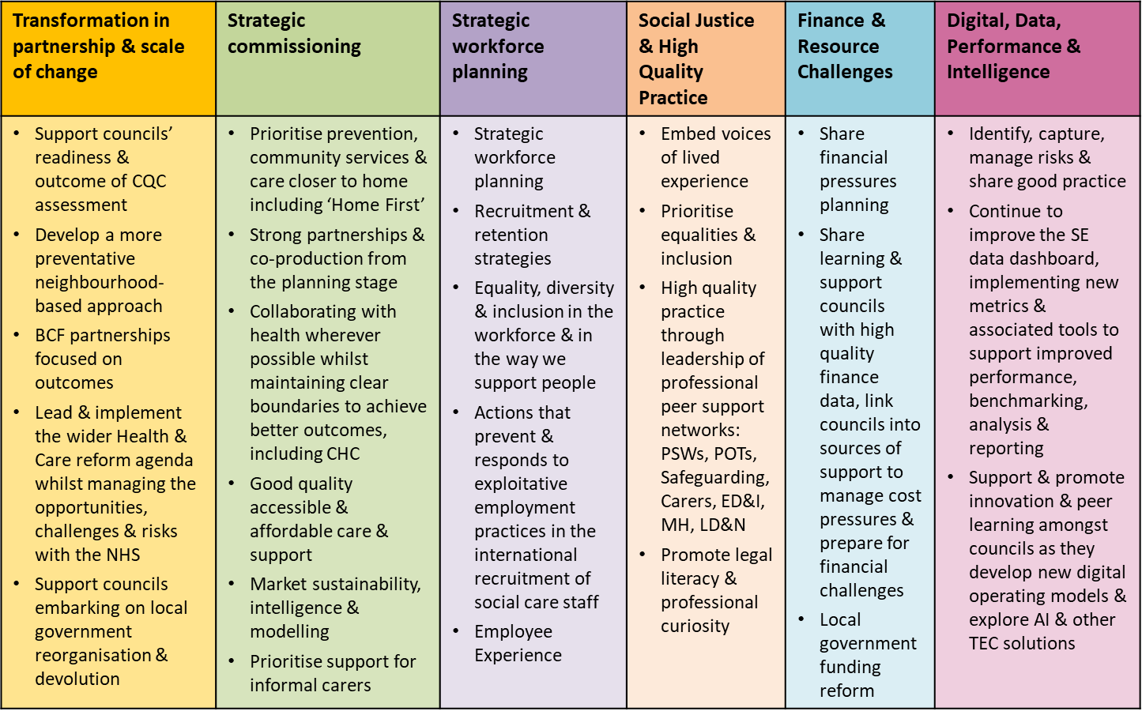

**Principles of the Vision and Priority outcomes**

There are many principles which thread through our vision and priorities, some of which go beyond adult social care, but which are integral to achieving our vision. No one single delivery mechanism will deliver these, but the principles below should feature across the delivery plans for all councils in the region. These are our starting point but will influence other work as we develop the priorities going forward.

1. **Co-production and personalisation**
   1. People’s journey is rarely confined to social care or health and housing, people do not live in silos, we live rounded lives with multiple and changing requirements, wishes and needs. So, within the region we recognise this and want to act upon it.
   2. Thinking about the care and support journey from an individual and family carer’s point of view and seeking to make such journeys as simple and straightforward as possible, regardless of how often the individual moves between different organisations. Our ambition as a region is to draw on the experiences, skills, and abilities of people in the community to create services together that are fit for purpose, based on inclusiveness, personalised support and choice.
2. **Community Based support service delivery model** 
   1. Creation of delivery models that ensure people have access to the right care and support at the right time and in the right place, strengthening our vibrant, safe, and supportive communities.
   2. We will work together with health, housing, community and voluntary sector organisations and people to deliver “asset based” approaches, where we place the emphasis on people’s and communities’ assets, alongside people’s needs, promoting neighbourhood working and independence.
3. **Equality, Diversity & Inclusion**
   1. Promote a diverse and inclusive workforce which better reflects communities, ensuring equality of opportunity, dignity, and respect and which embeds fair values, practices, and behaviours within workplaces.
   2. Reach all people in our communities.
4. **Accommodation with care**
   1. Modernised alternatives to residential care, such as extra-care housing, that are fit for purpose, technology enabled, designed with people who use housing with support and ensuring access to good quality affordable service provision.
   2. Good housing is a key determinant of health and well-being it is also a key determinant of people’s sense of home and community. We will influence and work with social landlord’s/ house builders in the thinking and designing future models which help people to live at home.
5. **Economic growth**
   1. Adult social care has enormous community wealth potential. We want to interrogate our data and intelligence to tell a different story.



**Achieving our vision and priority objectives**

* The sector-led improvement regional programme will be overseen by the SE ADASS Branch and SE ADASS Sector-Led Improvement Executive Board
* The ADASS regional team provides strategic support through bringing together senior leads across the region, managing, and reporting on the work programme and sharing intelligence and analysis to shape improvement across the region.
* All Boards / Groups / Networks are led by a Director of Adult Social Services (DASS) or Assistant/Deputy Director or a representative of the region with a special interest in the area of work and will support and input to drive the ambition for the region.
* The work will form part of the Sector-Led Improvement regional programme and will be monitored through the South East region’s governance infrastructure (see Network diagram below)

**Document last reviewed:** 28 May 2025

1. [socialcarefuture.org.uk](https://socialcarefuture.org.uk/)
2. Short and Long Term (SALT) Data Return 2023/24
3. <https://www.skillsforcare.org.uk/Adult-Social-Care-Workforce-Data/Workforce-intelligence/publications/regional-information/My-region.aspx>, based on LA data from September 2023 and independent sector data in March 2024 <https://www.skillsforcare.org.uk/adult-social-care-workforce-data/adult-social-care-workforce-data.aspx>